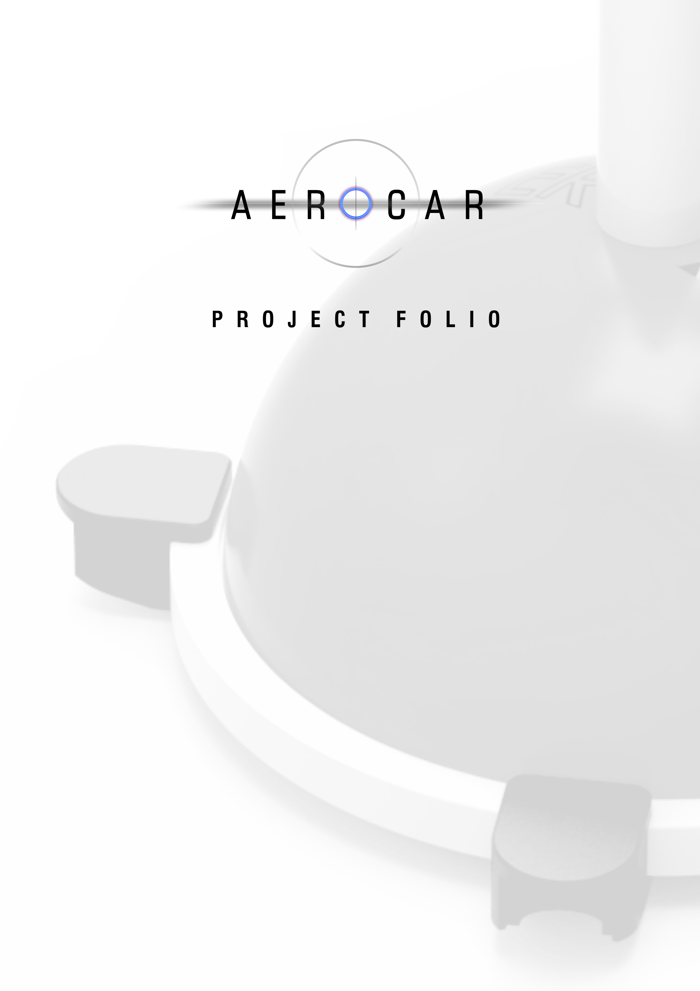

Name
Class

Contents |  | Introduction  Questions  Brief  Process  Method  Results  Evaluation

Introduction

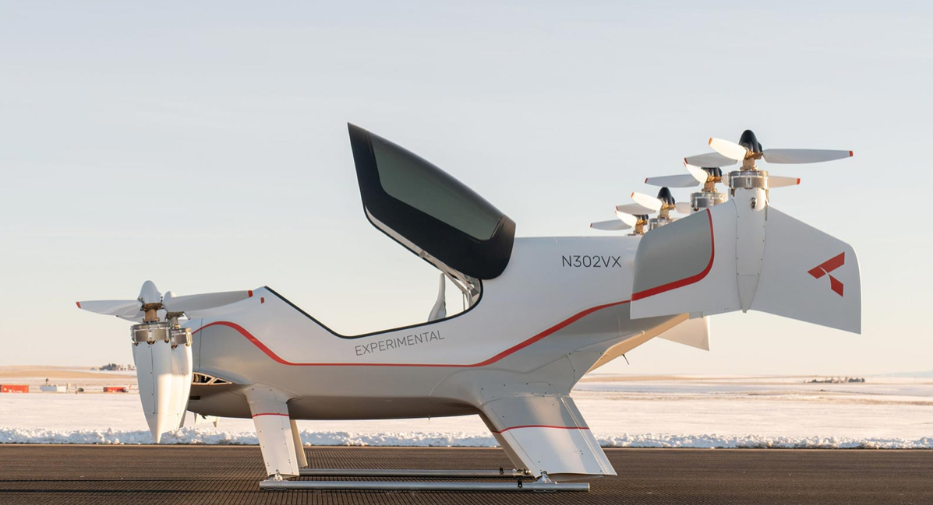

From the Jetsons to Bladerunner to Harry Potter, the idea of a flying car has captured the collective imagination for decades. And now, with the advent of high-tech drones, we can start to see a way that it might even become a reality. None of the current ideas look quite as wonderful as what we see in the movies. There is a lot of work to be done.

Improvements will be made through an experimental design process: understanding how things work by making and testing ideas and not being afraid of failure. This is also the approach taken in this project.

Brief
Design and make a propeller driven car to be used with the PowerAnchor. It needs to be fast, stable and light-weight and it needs to fly. You will be provided with 4 wheels, 2 axles, 1 motor, 1 propeller.

The only way success is judged in this project is how much flight your Aerocar can achieve.

Design parameters:
- Your Aerocar must have 4 wheels and two axles. These push together with the axle going through the coreflute.
- You cannot modify or cut into the coreflute body provided.
- Possible materials to use for the wings are: Balsa wood, cardboard, featherboard, coreflute, polypropylene.
- Possible joining systems are hot glue, acrylate glue (eg: Tarzan’s grip), wire, sticky tape, plasticine, pins
- You can use any wing system you like
- It must withstand crashing

Design concepts for initial model:

Complete sketches here

Testing

Complete the tables below.

Choose a physical feature to change on your Aerocar. This is the variable. Measure and record its value. Complete several test using different values for the variable. Make observations and propose some reasons for your observations.

Compete a test series for several variables. You will probably need to do significant modifications between test series.

Test series 1

Variable being changed (a physical feature of the car)

Values for the variable being changed. Test for each value.

Observations. What do you see happening?

Theorise. Why do you think your plane is behaving as it is? How does the chosen variable affect flight behaviour?

Test series 2

Variable being changed (a physical feature of the car)

Values for the variable being changed. Test for each value.

Observations. What do you see happening?

Theorise. Why do you think your plane is behaving as it is? How does the chosen variable affect flight behaviour?

Test series 3

Variable being changed (a physical feature of the car)

Values for the variable being changed. Test for each value.

Observations. What do you see happening?

Theorise. Why do you think your plane is behaving as it is? How does the chosen variable affect flight behaviour?

Test series 4

Variable being changed (a physical feature of the car)

Values for the variable being changed. Test for each value.

Observations. What do you see happening?

Theorise. Why do you think your plane is behaving as it is? How does the chosen variable affect flight behaviour?

Test series 5

Variable being changed (a physical feature of the car)

Values for the variable being changed. Test for each value.

Observations. What do you see happening?

Theorise. Why do you think your plane is behaving as it is? How does the chosen variable affect flight behaviour?

A photo or sketch of my most successful Aerocar.

Evaluation questions

- Do you think that your Protocar would be able to be made at a larger scale?

- What design modifications would be needed?

- Did your modifications always result in better performance?

- What does this tell you about the nature of experimental design?

- What do you think the future of automotive design will be?

- Do you expect to see radical changes like a flying car in your lifetime?

Watch http://www.youtube.com/watch?v=E4jpQGV_1Hw&feature=related

- What are the similarities between your experience in this project and James Dyson’s experience?

